Project Synopsis

on

**Prediction of TEC variations with Artificial Intelligence using Space Weather Data as input**

Submitted as a part of course curriculum for

**Bachelor of Technology**

in

**Computer Science**

# TITLE PAGE



**Submitted by**

Ananya Srivastava(2100290120028)

Aryan Kaushik(2200290129006)

Manas Rai(2100290120100)

**Under the Supervision of**

Dr. Harsh Khatter

Associate Professor

**KIET Group of Institutions, Ghaziabad**

**Department of Computer Science**

**Dr. A.P.J. Abdul Kalam Technical University**

**2023-2024**

**ACKNOWLEDGEMENT**

It gives us a great sense of pleasure to present the synopsis of the B.Tech Mini Project undertaken during B.Tech. Third Year. We owe a special debt of gratitude to Dr. Harsh Khatter (Associate Professor), Department of Computer Science, KIET Group of Institutions, Delhi- NCR, Ghaziabad, for his constant support and guidance throughout the course of our work. His sincerity, thoroughness and perseverance have been a constant source of inspiration for us. It is only his cognizant efforts that our endeavours have seen the light of the day.

We also take the opportunity to acknowledge the contribution of Dr. Ajay Kumar Shrivastava, Head of the Department of Computer Science, KIET Group of Institutions, Delhi- NCR, Ghaziabad, for his full support and assistance during the development of the project. We also do not like to miss the opportunity to acknowledge the contribution of all the faculty members of the department for their kind assistance and cooperation during the development of our project.

Last but not the least, we acknowledge our friends for their contribution to the completion of the project.

Dr. Harsh Khatter

Guide Name & Signature

Signature:

Student’s Name: Ananya Srivastava

Roll No: 2100290120028

Signature:

Student’s Name: Aryan Kaushik

Roll No: 2200290129006

Signature:

Student’s Name: Manas Rai

Roll No: 2100290120100

# TABLE OF CONTENTS

TITLE PAGE 1

TABLE OF CONTENTS 3

ABSTRACT 4

CHAPTER 1 INTRODUCTION 5

1.1 Problem Statement 6

1.2 Objectives 7

1.3 Scope 9

CHAPTER 2 LITERATURE REVIEW 10

PREDICTION OF TEC VARIATION USING SPACE WEATHER DATA AND AI 11

Ionospheric TEC Prediction Performance of ARIMA and LSTM Methods in Different Space Weather Conditions 12

Prediction of Ionospheric TEC Based on the NARX Neural Network 14

A Machine Learning-Based Method for Modelling TEC Regional Temporal-Spatial Map 16

TEC MEASUREMENTS WITH GPS DATA 18

Statistical analysis of ionospheric total electron content (TEC): long-term estimation of extreme TEC in Japan 19

Study the Ionospheric Total Electron Content (TEC) variation during Geomagnetic Storm in 24th Solar Cycle 21

Predicting the Ionospheric Total Electron Content using Adaptive Regression Model 22

CHAPTER 3 METHODOLOGY 24

CHAPTER 4 CONCLUSION 26

REFERENCES 27

# ABSTRACT

The effect of Space weather is usually linked to disturbances in the ionosphere (gradients in the Total electron content (TEC). This has significant effect especially for GPS users causing degradation in range measurements, loss of lock by the receiver of the GPS signal. The ionospheric electron density is sensitive to the space weather parameters like sunspot numbers, F10.7, interplanetary magnetic field etc. and shows variation with respect to them.

In this study, we propose a novel ionospheric TEC forecasting model based on deep learning and suitable machine learning algorithms. We are using the TEC data from IONOLAB (www.ionolab.org) for training the model. For space weather multiple sources are being utilised, such as WDC for Geomagnetism, Kyoto (WDC.kugi.kyoto-u.ac.jp). Disturbances in the ionosphere can cause degradation in range measurements and loss of lock by GPS receivers. The prediction model will be hosted on a website application. Our model uses observation data from the International Reference Ionosphere (IRI) to accurately model and forecast ionospheric TEC. Furthermore, we plan to host our prediction model on a website application for easy access and user convenience. The prediction will be in the form value of TEC variation and the graphical version in the form of graph. This web application is very convenient to use and just requires a web browser and data connection to work properly. This model is currently working on specific locations of India. This model will determine the TEC variation of those locations.

# CHAPTER 1 INTRODUCTION

The ionosphere is a region of the Earth's atmosphere where the Sun's ultraviolet radiation ionizes the neutral particles, creating free electrons and ions. The ionosphere is divided into several layers based on the altitude and the presence of ions and electrons. The layer of interest for TEC prediction is the F2 layer, which lies between 200 and 400 km above the Earth's surface.

The TEC values are calculated by integrating the electron density along the path from the GNSS satellite to the receiver. It is ionized by solar radiation and cosmic rays, creating free electrons and ions. The ionosphere is divided into several layers based on the altitude, such as D, E, and F layers. The D layer is the lowest layer and is mostly responsible for absorption of radio waves, while the F layer is the highest and reflects radio waves.

The electron density in the ionosphere is not constant and varies due to various factors such as solar radiation, geomagnetic storms, and diurnal and seasonal changes. Hence, predicting the TEC values accurately requires a good understanding of the ionosphere's dynamics and the factors that affect it.

The ionosphere is a three-dimensional dispersive medium atmosphere layer whose primary driver is the Sun. The layer locates above approximately 50-1000 km from the Earth's surface and includes molecules with potential for photoionization. When molecules are exposed to light energy emitted from the Sun, their components are divided into atoms, which are negative electrons and positive ions. Negatively charged electrons affect the propagation of electromagnetic signals traveling between the earth and space.

The number of free electrons is described by the Total Electron Content (TEC) parameter. The TEC describes the number of free electrons in a cylinder with a 1 m2 base area throughout the line-of-sight (LOS). The unit of the TEC (TECU) is equal to 1016 electron/m2. TEC values have periodic temporal and spatial variations such as the diurnal, 27-day, seasonal, semi-annual, annual, and 11-year under control of the Sun. The TEC also increase/decrease due to space weather events such as solar winds, solar flares, geomagnetic storms, volcanic eruptions, hurricanes/typhoons and anthropogenic events. These events generally cause non-secular changes and affects the regular change of TEC variation. There are some traditional time series analysis methods to modeling the TEC time series, but these methods are not adequate to simulation the previous TEC observation and the pattern that is far away from forecasting-initial-point, as any artificial intelligence (AI) algorithms. However, AI method such as ARIMA and LSTM learns the trend, seasonality, and residuals patterns in the TEC time series and successfully forecasting TEC values for a short period. Some AI-based methods were previously utilized to forecast ionospheric parameters. The forecasting performance of the methods was compared using some statistical metrics.

## 1.1 Problem Statement

**Prediction of TEC variations with Artificial Intelligence using Space Weather Data as input**

* The primary aim is to forecast variations in the Ionospheric Total Electron Content (TEC) utilizing Artificial Intelligence (AI) methodologies, with Space Weather Data serving as the primary input.
* Understanding TEC fluctuations is crucial for users of radio-based systems, such as Global Navigation Satellite Systems (GNSS) and high-frequency communication systems. Predicting TEC variations can help mitigate potential disruptions caused by space weather phenomena.
* TEC variations are influenced by multiple factors, including solar activity, geomagnetic conditions, and atmospheric disturbances. These interactions create a complex and dynamic environment that requires advanced predictive models to accurately forecast TEC behavior.
* Space weather parameters, such as solar activity indices and geomagnetic data, play a crucial role in TEC prediction. Incorporating these data sources into predictive models is essential for capturing the underlying drivers of TEC variations.
* Developing accurate TEC prediction models using AI techniques poses several challenges, including data complexity, model interpretability, and generalization across diverse geographic regions and ionospheric conditions.
* The successful prediction of TEC variations has wide-ranging applications, including improving the accuracy of GNSS positioning, optimizing satellite communication networks, and enhancing the resilience of radio-based systems to space weather impacts.

## 1.2 Objectives

The objectives of the topic "Prediction of TEC variations with Artificial Intelligence using Space Weather Data as input" aim to address the challenges and improve the accuracy of TEC prediction while leveraging AI techniques and incorporating space weather data. Here are the objectives explained properly in pointers:

* **Develop AI-Based Prediction Models**: Create advanced machine learning and deep learning models tailored to predict TEC variations accurately. These models should effectively capture the complex relationships between space weather data and TEC dynamics.
* **Integration of Space Weather Data**: Incorporate diverse space weather data, including solar activity parameters (e.g., F10.7 index, sunspot number) and geomagnetic conditions, into the prediction models. Ensure that the integration process preserves the meaningful relationships between different data sources.
* **Enhance Model Interpretability**: Design AI models that provide insights into the underlying mechanisms driving TEC predictions. Ensure interpretability by employing techniques such as feature importance analysis and model visualization, allowing stakeholders to understand and trust the prediction outputs.
* **Improve Prediction Accuracy**: Employ rigorous model training, validation, and evaluation processes to enhance the accuracy and reliability of TEC predictions. Utilize space weather data to refine model parameters and optimize prediction performance under varying solar and geomagnetic conditions.
* **Validate Models Across Different Regions**: Validate the developed prediction models across diverse geographic regions to assess their generalization capabilities. Ensure that the models demonstrate consistent and reliable performance across different latitudes and longitudes.
* **Website Prediction for TEC Prediction**: Development of a dedicated website to showcase cutting-edge research and advancements in predicting Ionospheric Total Electron Content (TEC) variations using Artificial Intelligence (AI) techniques and space weather data. This interactive platform will provide users with insights into the significance of TEC prediction, along with dynamic visualizations demonstrating the accuracy and reliability of our prediction models.
* **Comparison with Traditional Methods**: Compare the performance of AI-based prediction models with traditional methods, such as statistical approaches or empirical models like the International Reference Ionosphere (IRI). Quantify the improvements in prediction accuracy achieved by AI-based approaches over existing methods.
* **Facilitate Accessibility and Usability**: Develop user-friendly interfaces or web applications to facilitate the accessibility and usability of TEC prediction models. Ensure that stakeholders, including researchers, engineers, and operators of radio-based systems, can easily access and utilize the prediction outputs for decision-making.

In summary, the objectives aim to advance TEC prediction capabilities by leveraging AI techniques, integrating space weather data, enhancing model interpretability, and improving prediction accuracy, ultimately benefiting various applications in radio-based systems.

## 1.3 Scope

The scope of the project "Prediction of TEC variations with Artificial Intelligence using Space Weather Data as input" encompasses the following areas:

1. **Development of Prediction Models**: The project will focus on designing and developing machine learning and deep learning models specifically tailored for predicting Ionospheric Total Electron Content (TEC) variations. These models will utilize Artificial Intelligence (AI) techniques to analyze and learn from historical TEC data in conjunction with space weather data as input.

2. **Integration of Space Weather Data**: The project will involve integrating diverse space weather data, including solar activity parameters (e.g., F10.7 index, sunspot number) and geomagnetic conditions, into the prediction models. The integration process will ensure that the models can effectively capture the complex relationships between space weather phenomena and TEC dynamics.

3. **Model Interpretability and Evaluation**: Special emphasis will be placed on ensuring the interpretability of the developed prediction models. Techniques such as feature importance analysis and model visualization will be employed to provide insights into the underlying mechanisms driving TEC predictions. Additionally, rigorous evaluation procedures will be implemented to assess the accuracy and reliability of the models.

4. **Validation Across Different Regions**: The project will validate the developed prediction models across diverse geographic regions to assess their generalization capabilities. Validation efforts will include testing the models across different latitudes and longitudes to ensure robust performance under varying ionospheric conditions.

5. **Website Prediction for TEC Prediction**: Development of a dedicated website to showcase predicted Ionospheric Total Electron Content (TEC) variations using Artificial Intelligence (AI) techniques and space weather data. This interactive platform will provide users with insights into the significance of TEC prediction, along with dynamic visualizations demonstrating the accuracy and reliability of our prediction models.

6. **Predicting previous data**: The model should be able to predict and fill gaps in TEC observation data.

In summary, the scope of the project encompasses the development, integration, evaluation, validation, and application of AI-based prediction models for TEC variations, with the ultimate goal of enhancing the performance and reliability of radio-based systems in the presence of space weather effects.

# CHAPTER 2 LITERATURE REVIEW

|  |  |
| --- | --- |
| Author | Title |
| Tharun Racharla, Sakshi Rajurkar, Saurabh Sakharkar, Aman Mishra, Sarvesh Warjurkar | PREDICTION OF TEC VARIATION USING SPACE WEATHER DATA AND AI |
| Erman Şentürk | Ionospheric TEC Prediction Performance of ARIMA and LSTM Methods in Different Space Weather Conditions |
| Liu Guoyan, Gao Wang, Zhang Zhengxie, and Zhao Qing | Prediction of Ionospheric TEC Based on the NARX Neural Network |
| Yiran Liu, Jian Wang, Cheng Yang, Yu Zheng, Haipeng Fu | A Machine Learning-Based Method for Modelling TEC Regional Temporal-Spatial Map |
| Ivan J. Kantor, Eurico R. de Paula, Luiz Felipe C. de Rezende | TEC MEASUREMENTS WITH GPS DATA |
| Michi Nishioka, Susumu Saito, Chihiro Tao, Daiko Shiota, Takuya Tsugawa, Mamuro Ishii | Statistical analysis of ionospheric total electron content (TEC): long-term estimation of extreme TEC in Japan |
| Subrata Kundu, Sudipta Sasmal, Suman Chakraborti, Sandip K. Chakrabarti | Study the Ionospheric Total Electron Content (TEC) variation during Geomagnetic Storm in 24th Solar Cycle |
| Sumitra Iyer, Alka Mahajan | Predicting the Ionospheric Total Electron Content using Adaptive Regression Model |

## PREDICTION OF TEC VARIATION USING SPACE WEATHER DATA AND AI

*(Authors: Tharun Racharla, Sakshi Rajurkar, Saurabh Sakharkar, Aman Mishra, Sarvesh Warjurkar )*

A novel ionospheric Total Electron Content (TEC) forecasting model is proposed using deep learning and Random Forest classifier algorithm. The model uses observation data from the International Reference Ionosphere (IRI) to predict TEC variation. The F2 layer, located between 200 and 400 km above the Earth's surface, is the focus for TEC prediction. The ionosphere is divided into layers based on altitude and the presence of ions and electrons. The model requires a good understanding of the ionosphere's dynamics and factors affecting it. The dataset contains 185,389 observations and a mean year of 2016. The results show that increasing the number of maximum leaf nodes improves the model's performance. However, there may be a trade-off between model performance and computational complexity. The required website application program for predicting TEC variations based on user input parameters is being developed successfully using the python Flask web framework and various Python libraries. The machine learning model is accessed through an efficient, scalable, and secure application. It provides input forms for user interaction and can be scaled to meet deployment requirements. Passwords are encrypted using SHA256 hashing.

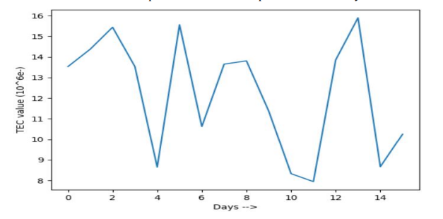

*(Source: Taken from the research paper “PREDICTION OF TEC VARIATION USING SPACE WEATHER DATA AND AI”)*

## Ionospheric TEC Prediction Performance of ARIMA and LSTM Methods in Different Space Weather Conditions

*(Author: Erman Şentürk)*

This study examines the performance of artificial intelligence (AI) techniques, including machine learning-based methods like ARIMA and long short-term memory (LSTM) networks, in predicting Total Electron Content (TEC) values. The ionosphere is a three-dimensional dispersive medium atmosphere layer above Earth's surface, containing molecules with potential for photoionization. TEC values have periodic temporal and spatial variations due to space weather events such as solar winds, geomagnetic storms, earthquakes, volcanic eruptions, hurricanes/typhoons, and anthropogenic events. Traditional time series analysis methods are not adequate for simulating previous TEC observations, so AI algorithms like ARIMA and LSTM can successfully forecast TEC values for a short period. The study compares the advantages and disadvantages of ARIMA and LSTM methods for ionospheric TEC forecasting. The TEC time series was obtained from the Center for Orbit Determination in Europe – Global Ionosphere Maps (CODE-GIMs) and used for two-time intervals for quiet space weather and a geomagnetic storm.

Time series data, such as TEC variation, is influenced by previous observations rather than independent variables. Traditional Artificial Neural Networks (ANN) can capture irregularities but struggle with vanishing gradients, a problem known as vanishing gradient. LSTM-RNN networks overcome this issue by keeping learning within the network and forecasting based on it. The study splits the dataset into training and test parts, analyzing quiet space weather and geomagnetic storm periods. The results showed quiet space weather for ionospheric variation except for a moderate geomagnetic storm on April 20, 2020. The ARIMA and LSTM models had accuracy of 2.24 and 1.43 TECU, respectively, for quiet space weather and geomagnetic storm periods, respectively.

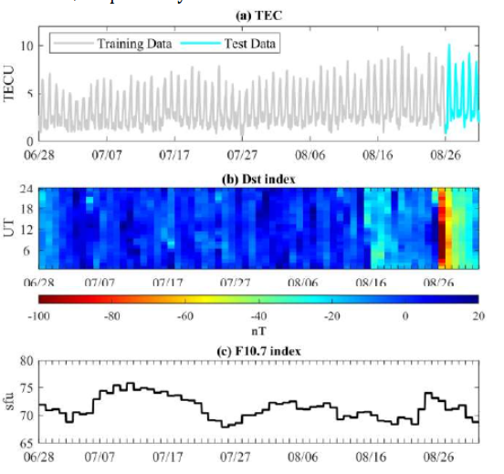

*(Source: Taken from the research paper “Ionospheric TEC Prediction Performance of ARIMA and LSTM Methods in Different Space Weather Conditions”)*

The gray and cyan lines indicate training and test data, respectively.

## Prediction of Ionospheric TEC Based on the NARX Neural Network

*(Authors: Liu Guoyan, Gao Wang, Zhang Zhengxie, and Zhao Qing)*

This paper presents an ionospheric total electron content (TEC) prediction method using the nonlinear autoregressive with exogenous input (NARX) neural network. The method uses previous TEC ata and external time parameter inputs to establish a prediction model. 12 datasets of 3 stations with different latitudes are used for experiments, with each dataset using the first 120 days for training and the next 20 days for testing. The results show that the NARX network can improve TEC prediction accuracy by 32.3% and 43.5% in the year with active solar activity (2011) and 20.7% and 22.7% in the year with calm solar activity (2017). The ionosphere, located 60-1000 km from Earth's surface, is ionized by atmospheric molecules due to solar radiation and cosmic rays. The paper uses the International GNSS Service (IGS) TEC map as the ionospheric prediction target, interpolating TEC at any point and forming a single-point TEC time series. This paper proposes a TEC prediction method using the NARX network, which processes TEC information as a time series based on ionosphere changes. The method uses data from IGS ionospheric grid products and raw observations of GNSS receivers. The NARX algorithm has the highest accuracy in TEC predictions, with RMSEs between 1.501 TECU and 3.722 TECU in 2011 and 1.049 TECU and 2.728 TECU in 2017.

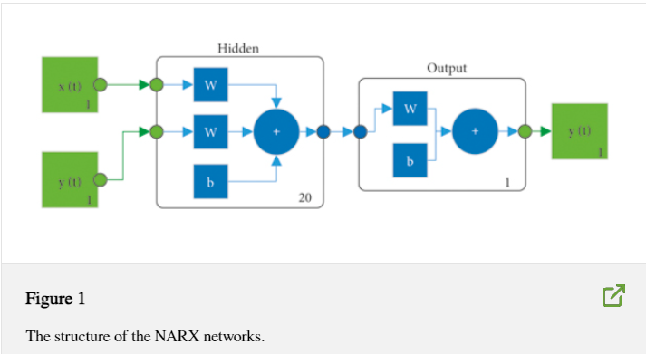

*(Source: Taken from the research paper “Prediction of Ionospheric TEC Based on the NARX Neural Network”)*

## A Machine Learning-Based Method for Modelling TEC Regional Temporal-Spatial Map

*(by*[*Yiran Liu*](https://sciprofiles.com/profile/2469629?utm_source=mdpi.com&utm_medium=website&utm_campaign=avatar_name)*, Jian Wang,* [*Cheng Yang*](https://sciprofiles.com/profile/2190709?utm_source=mdpi.com&utm_medium=website&utm_campaign=avatar_name)*, Yu Zheng, Haipeng Fu)*

The study proposes a machine learning-based model for predicting the total electron content (TEC) of the regional ionosphere for satellite navigation, positioning, measurement, and controlling. The model uses principal component analysis, solar activity parameters, and modified Kriging spatial interpolation to create an empirical prediction model for parts of Europe. The model's coefficients and harmonic numbers are determined using the root mean square error (RMSE) and relative value (RRMSE). The model's monthly mean values are highly consistent with observed values, with a RRMSE of 12.76%. The ionosphere, located between 60 and 1000 km above the ground, is influenced by factors like solar radiation, geomagnetic disturbance, and atmospheric activity. It experiences periodic variations in day, month, season, year, and complex synoptic and climatological changes. Mastering the distribution of electron content (TEC) is crucial for systems like GNSS and VLBI. Accurately reflecting the distribution of electron content in the ionosphere is important for applications like satellite communication, navigation, positioning, measurement, and disaster prevention. TEC can be directly measured by the ionospheric sounder or indirectly inverted by carrier phase delay. The international reference ionosphere (IRI) is the most common empirical model, and recent research has introduced machine learning and deep learning methods to improve the accuracy of empirical models. Examples include a recurrent neural network (RNN) model based on deep learning, ionospheric TEC prediction models based on long short-term memory (LSTM), and a multi-step auxiliary LSTM algorithm to alleviate increasing error with prediction time. The study explores the use of generative adversarial networks (GAN) and conditional GAN in predicting ionospheric TEC. It also discusses the use of artificial neural networks (ANN), LSTM networks, adaptive neuro-fuzzy inference systems, and gradient boosting decision tree (GBDT) in modeling ionospheric TEC. The study also introduces new modeling ideas and prediction results. The regional model has shown higher prediction accuracy compared to the global model. The study also discusses the development of regional TEC models, such as the European TEC prediction model based on thin-plate splines (TPS) interpolation. The study also discusses the use of ML-based modeling methods to improve TEC prediction accuracy in Europe. The proposed method aims to make the model more interpretable and simple. The TEC model is a complex system that involves temporal-spatial dynamic variations. Traditional methods rely on mathematical principles, while intelligent methods like machine learning (ML) are emerging to promote leapfrog development. ML is interdisciplinary, building probabilistic statistical models based on data and using them to predict and analyze data. It is widely applied in modeling various ionospheric parameters. The model is trained using monthly mean values of TEC from eight ionospheric observation stations in Europe. To choose a suitable model, an in-depth understanding of the purpose, principles, and scope of different models is required. The principal component analysis (PCA) function set is selected as the hypothesis space to construct the temporal and spatial characteristic map of TEC. PCA reduces the number of parameters involved in the modeling process and the amount of calculation and storage of intermediate data, achieving high accuracy and fast convergence. The least-squares (LS) regression analysis algorithm is used to determine the parameters of the model, due to its advantages of simple calculation, short modeling time, easy understanding, and high sensitivity to outliers. The TEC curve predicted by the IRI model and the proposed model closely resembles the observed curve, with significant variation in day, month, season, and year. The maximum TEC value is higher in high solar activity years. The proposed model is closer to the TEC observation curve, particularly in Roquetes and Dourbes. However, both models have the highest prediction error in Nicosia due to the complex ionosphere dynamics and insufficient observation data. The IRI model also showed double peaks in CCIR and URSI coefficients, resulting in higher prediction errors. This paper presents an ML-based model for predicting TEC in parts of Europe. The model is found to be highly consistent with the observed TEC curve and has significantly better prediction accuracy than the IRI model. The model's effectiveness is confirmed by an improvement of 38.63% and 35.79% compared to the IRI model. The model's effectiveness is expected to improve early warning for natural disasters and sudden magnetic storms by collecting more data and expanding its application scope. Further improvements are planned for other ionospheric parameters.

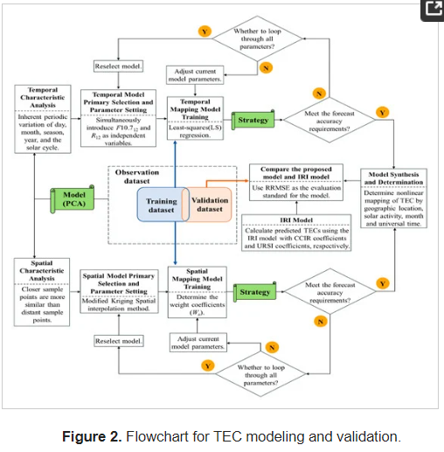

*(Source: Taken from the research paper “A Machine Learning-Based Method for Modelling TEC Regional Temporal-Spatial Map”)*

## TEC MEASUREMENTS WITH GPS DATA

*(Ivan J. Kantor, Eurico R. de Paula, Luiz Felipe C. de Rezende)*

The Total Electron Content (TEC) is a crucial geophysical parameter used to correct navigation measurements for single frequency receivers. It is measured using the Faraday Rotation effect on a linear polarized propagating plane wave. GPS data is used for TEC measurements, providing at least 4 and up to 9 TEC values within 1000 km of the receiving station every 30 seconds. The Global Positioning System (GPS) is a complex and expensive constellation of 24 satellites distributed in 6 orbital planes, with an orbit inclination of 55 degrees and a 12-hour period. The carrier phase observations have sometimes a sudden jump, that is removed ("cycle slip correction") by adjusting the continuity of (Φ1 - Φ2). This can be done by adjusting a polynomial to some data before and after the cycle slip occurrence.

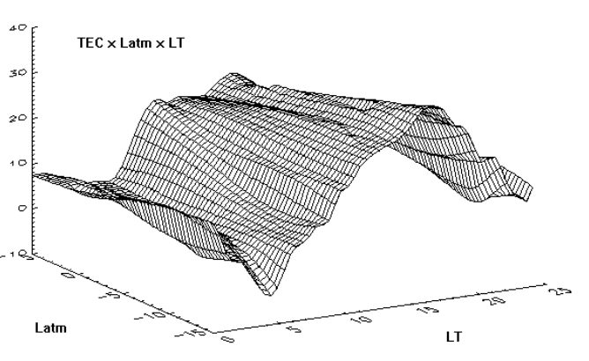

Plot for TEC

*(Source: Taken from the research paper “TEC MEASUREMENTS WITH GPS DATA”)*

## Statistical analysis of ionospheric total electron content (TEC): long-term estimation of extreme TEC in Japan

*(Michi Nishioka, Susumu Saito, Chihiro Tao, Daiko Shiota, Takuya Tsugawa, Mamuro Ishii)*

This study aims to estimate extreme ionospheric total electron content (TEC) values in Japan for once per year, 10 years, and 100 years. The data is derived from 22 years of TEC data from 1997 to 2018, with extreme values of 90 and 110 TECU for once per year and 10 years respectively. The study uses 62-year data set of manually scaled ionosonde data for the critical frequency of the F-layer (foF2) at Kokubunji in Tokyo. The results show that the once-per-100-year TEC is around 150-190 TECU at Tokyo. The ionospheric condition is crucial for radio-based systems, such as GNSS navigation systems, high-frequency communication systems, and remote sensing systems. It involves a delay in group velocity and advance in phase velocity due to electrons in the ionosphere. The ionospheric delay is proportional to the ionospheric total electron content (TEC) along the propagation path. The TEC value is determined by factors such as solar activity, the season, local time, and geomagnetic activity. However, geomagnetic storms and other phenomena cannot be fully removed from these models. Users of radio-based systems may be affected by positive and/or negative ionospheric storms.  
Extreme values of some space weather parameters have been studied, but extreme TEC values of once per long period of time have not yet been quantitatively estimated. The US White House published "Space Weather Phase 1 Benchmarks" in June 2018, but the ionospheric effects of geomagnetic storms on the ionosphere largely differ from event to event and their mechanism is not completely understood. This study aims to estimate extreme values of TEC with their occurrence rates in Japan in the short, mid-, and long term. This study uses 60 years of data from ionosonde observation to evaluate the occurrence rate of tectonic activity (TEC) once per 100 years. Solar activity in the last 20 years has been moderate, with several intense geomagnetic storms occurring during solar cycle 24. Ionosonde observation has a longer history, developed in the late 1920s and implemented in Japan in the 1940s. The study investigates the statistical characteristics of extreme TEC values to estimate the ionospheric once-per-100-year condition. The TEC value over Japan depends on latitude, with a larger value in southern Japan. The study uses 20 years of TEC data collected in Tokyo and analyzes long-term ionosonde data to estimate extreme TEC values with probabilities of once per year, 10 years, and 100 years for Tokyo and southern and northern Japan. This study uses TEC data from the GNSS Earth Observation Network System (GEONET) and ionosonde observation data from Tokyo. The slant TEC is derived from pseudo-range and carrier-phase measurements by dual-frequency GPS receivers. The instrumental bias of the TEC is obtained by assuming that hourly averaged TEC values are uniform within the field of view of a given GNSS receiver. The largest hourly TEC in a given day is noted as the daily TEC. Ionospheric conditions have been monitored for about 70 years by NICT using ionosondes in Kokubunji, Tokyo. Ionospheric parameters have been manually scaled from ionograms, and the study uses the manually scaled critical frequency of the F-layer (foF2) to study foF2 with the daily TEC. The cumulative distribution function (CDF) of daily TEC occurrence is used to find extreme values of TEC with an occurrence frequency of once every certain number of years. This method provides an occurrence probability of a daily TEC greater than or equal to a certain value, unlike a normal distribution. However, a data set of TEC values over 22 years is insufficient for investigating TEC values with an occurrence frequency of once per 100 years. To compensate for this, a 62-year data set of foF2 values was used to calculate NmF2 and study the relationship between TEC and foF2. However, the data is insufficient, as the occurrence rate of a single event is larger than that of once-in-100-year events. The study analyzes the daily occurrence of tectonic activity (TEC) in Tokyo over 22 years, focusing on the daily TEC percentage. The occurrence rate is calculated as days per 100 years, with a probability of 0.3%. The daily TEC can reach about 90 TECU with a frequency of once per year. The occurrence probabilities of once per 10 years and once per 100 years are 0.03% and 0.003%, respectively. A daily TEC of more than 100 TECU occurs once per 10 years. The study also examines the daily occurrence of foF2 (fos2) over 22 and 62 years. The CDF of the daily foF2 occurrence is compared with the 22 years of TEC data. The occurrence frequencies of once per year, 10 years, and 100 years are 0.3%, 0.03%, and 0.003%, respectively. The results provide valuable insights into the occurrence of TEC and foF2 over different time periods. This study investigated extreme values of TEC with frequencies of once per year, 10 years, and 100 years. Results showed that once-per-year and once-per-10-year TECs were 90 and 110 TECU, respectively. To estimate once-per-100-year TEC, 62 years of manually scaled ionosonde data were used. Two methods were tested to compensate for the insufficient number of data: artificially inflated normal distributions and extreme slab thickness. Extreme TEC values were also studied in

Kagoshima and Hokkaido, with values varying for each region.

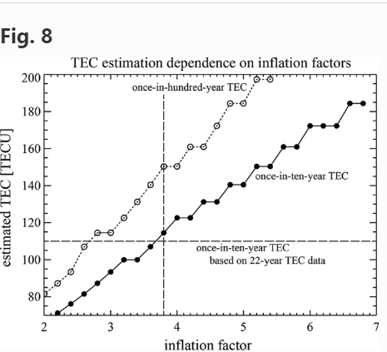

*(Source: Taken from the research paper “Statistical analysis of ionospheric total electron content (TEC): long-term estimation of extreme TEC in Japan”)*

## Study the Ionospheric Total Electron Content (TEC) variation during Geomagnetic Storm in 24th Solar Cycle

*Subrata Kundu, Sudipta Sasmal, Suman Chakraborti, Sandip K. Chakrabarti)*

The study used IGS dual-frequency GPS data from IISC, Bangalore, India, to investigate the Total Electron Content (TEC) and geomagnetic storms variation in the ionosphere. The data showed maximum diurnal variation in 2014 and decreased to a minimum in 2015-2017. During storm time, TEC increased compared to quiet day TEC, with a sharp decrease during negative storms. Geomagnetic storms disrupt the earth's magnetic field, affecting the ionospheric electron density and total electron content. There are two types of storms: positive and negative, corresponding to the enhancement and decrement in TEC. Ionospheric TEC is crucial for studying space weather phenomena, geodesy, communication, and positioning errors related to GPS. The ionospheric group path delay timing error is proportional to TEC, allowing for calculation of TEC from GPS data. Geomagnetic storms depend on the solar cycle, with less strong and intensive storms during the 24th solar cycle. Different models analyze geomagnetic storms during different solar activity periods, based on the minimum value of Dst during the storm occurrence. The study uses GPS data from the IGS station IISC in Bangalore, India, to compute the Slant Total Electron Content (STEC) and Vertical Electron Content (VTEC). The data ranges from 2007-2017, starting from the end of the solar cycle 23 to the end of the solar cycle 24. The maximum sunspot number during solar cycle 24 is determined by the monthly sunspot average variation. The Slant TEC is calculated using Gopi Seemala Software. The study also shows TEC variation during space weather events (Geomagnetic storms) and solar activity. The study uses GPS Rinex observation and navigation data to compute the TEC from the IGS data archive. The study selects four storms to study geomagnetic activity during the full solar cycle, taking one intense storm from each year from 2014-2017. Four storms were considered, with the strongest being the 17th March 2015 storm. The storm day was February 19th, 2014, with a strong Dst of -119nT. The maximum change in TEC was 44%. The storm day was March 17th, 2015, with a Dst of -223nT. The most intense storm of the solar cycle was on January 1st, 2016, with a Dst of -110nT. On September 8th, 2017, two storms occurred on the same day, with minimum Dsts of -142nT and -124nT respectively. The study reveals that TEC is high at equinoxes due to high solar activity and increased solar radiation. The F layer is influenced by the geomagnetic storm, leading to an increase in electron density. The diurnal variation of TEC is not symmetric around noon, reaching maximum values around 7:00-12:00 UT. Positive ionosphere storms are caused by neutral winds and electric field variations.

## Predicting the Ionospheric Total Electron Content using Adaptive Regression Model

*(Sumitra Iyer, Alka Mahajan)*

The Ionospheric Total Electron Content (TEC) significantly impacts satellite-based navigation systems' positional accuracy due to group delay in signals. Advanced estimation of TEC can improve performance and accuracy by incorporating real measurements and suitable corrections. This paper proposes using a regression method to predict TEC using an online machine learning model. The model is adaptive and suitable for short-term predictions in real-time. Comparative evaluations show the model is reliable in forecasting TEC values, reducing GPS error. The ionosphere plays a crucial role in satellite-based navigation systems, but it also negatively affects their performance. The ionosphere's properties, such as refraction, absorption, polarization, propagation time delay, Doppler frequency shift, and ionospheric scintillation, impact the propagating satellite signal, causing range error and determining receiver system accuracy. The estimation of TEC (thermoelectric constant) is essential for correcting the range error caused by the delay in the propagating signal. Dual-frequency receivers can mitigate ionospheric errors by using two signals at different carrier frequencies. However, single-frequency receivers require modeling, tracking TEC variation, and error correction. Current correction systems use the Klobuchar ionospheric model for error correction in single-frequency GPS. Grid-based traditional Satellite Based Augmentation Systems (SBAS) also aid in corrections for satellite position errors by estimating signal delay. However, spatial and temporal variation in the ionosphere affect estimation accuracy. Machine learning models like Neural Networks (NN), Support Vector Machine, and Genetic Algorithms have been widely used in satellite navigation. Some models have been proposed for predicting ionospheric vertical TEC one hour ahead using genetic algorithms and neural networks, but their scope is limited to mid-high latitudes. An improved model for regional ionosphere using combined support vector machine regression and 2D polynomial is proposed. However, these models require extensive training for each region, as TEC patterns are subject to spatial variation, especially in low and equatorial latitudes. ARIMA model is proposed for short-term prediction of ionospheric TEC with an average prediction accuracy of 83-86% for quiet and active days. Long Short-term Memory (LSTM) has been developed to predict ionospheric vertical TEC in Beijing, but its performance is dependent on training with region-wise data. Random Forest and Trees Gradient Boosting machine learning models have shown small RMSE on real data, but they are computationally expensive for standalone single frequency receivers. This paper focuses on developing an adaptive model for short-term apriori estimation of TEC in real time. The model uses data from the incoming vector of daily TEC at different time ranges and adapts to the variation in TEC and predicts TEC in advance. The model uses online machine learning technique and historical TEC data to model the level variation trend. The adaptive apriori TEC estimation model is tested using TEC variation data from the equinox month of March 2015, aiming to predict TEC for a future time without prior training. The model is tested for different days and times of the day, and the results are compared with ground truth values using coefficients of determination, MAE, and MSE. The study investigates the equatorial ionosphere (TEC) variation pattern over different solar cycles, seasons, diurnal and latitudinal variations, and various solar and geomagnetic indices. The Indian region is particularly affected due to its proximity to the geomagnetic equator and geographic spread over the northern equatorial ionization anomaly zone (EIA). The TEC distribution depends on the strength of the equatorial electrojet (EEJ), plasma fountain, equatorial ionization anomaly (EIA), equatorial wind, and temperature anomaly. The solar cycle, the Sun's magnetic field, also impacts the ionosphere's behavior. The scatter plot of TEC is examined for different locations at different times, revealing that TEC variation varies on each day due to varying solar and geomagnetic conditions within the 24th solar cycle. The TEC pattern trend remains almost the same in a particular latitude, with flattened peaks due to night-time enhancements and sharp peaks at Lucknow and Hyderabad. More detailed statistical studies are presented in the next section. Geomagnetic disturbances in the ionosphere directly influence the Earth's El Niño (EEJ) and TEC distribution in the equatorial region. The strength of these disturbances is measured using the Dst index, AE index, or Kp index. The influence of solar and geomagnetic indices on the TEC pattern was investigated using statistical significance tests. However, correlation coefficients with Dst and AE index are not consistent across different latitudes and time ranges.  
The exploratory data analysis revealed a curvilinear pattern that can be modelled using regression techniques. The study was carried out over an hour interval, as the Dst and AE index are available at one hour intervals. The predictive model must be adaptive in real-time and include incoming time series data of TEC. Data-driven methods are explored for estimating the TEC variation. The proposed model is developed using different regression methods, including regression analysis for prediction and forecasting. Linear and nonlinear regression techniques can be useful in modeling complex variations in TEC. The model is developed in different phases. In the first phase, simple linear regression is used. In the second phase, a polynomial prediction model is developed which uses polynomials in the linear regression. An adaptive model built using different regression techniques is explored in the third phase. The proposed polynomial predictive model and adaptive apriori estimation model predict the TEC for both quiet and storm days with fair accuracy and less than 5TECU error. The model uses online machine learning and is computationally expensive. The performance is satisfactory for small intervals but worse with increased intervals.

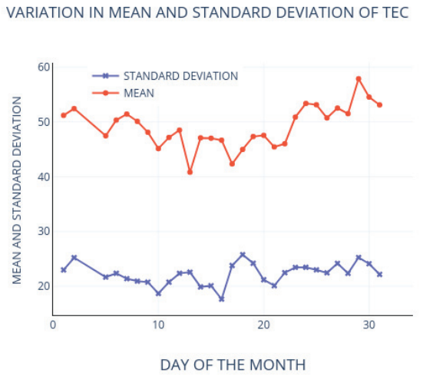

*(Source: Taken from the research paper “Predicting the Ionospheric Total Electron Content using Adaptive Regression Model”)*

# CHAPTER 3 METHODOLOGY

1. **Data Collection and Preprocessing**:

- Gather historical TEC data spanning multiple years from reliable sources such as ionosondes, GNSS receivers, or satellite-based observations. Additionally, collect space weather data including solar activity indices (e.g., F10.7 index, sunspot number) and geomagnetic conditions.

- Preprocess the collected data to ensure consistency and compatibility. This may involve cleaning, filtering, and interpolating missing values in the TEC and space weather datasets.

2. **Feature Selection and Engineering**:

- Conduct feature selection to identify relevant predictors for TEC variations. Consider variables such as solar activity indices, geomagnetic parameters, geographic location, and time of day.

- Perform feature engineering to derive additional predictors or transformations that may enhance the predictive capabilities of the model. This may include lagged variables, Fourier transformations for periodic patterns, or spatial features based on geographic coordinates.

3. **Model Development**:

- Select appropriate AI techniques for TEC prediction, such as machine learning algorithms (e.g., Random Forest, Support Vector Machines) or deep learning architectures (e.g., LSTM networks, CNNs).

- Design the model architecture considering the temporal and spatial characteristics of TEC variations. Experiment with different network structures, activation functions, and regularization techniques to optimize model performance.

- Train the model using the preprocessed data, partitioning it into training, validation, and test sets. Utilize techniques such as cross-validation to assess model generalization and prevent overfitting.

4. **Model Interpretability and Evaluation**:

- Incorporate interpretability techniques to enhance the transparency of the model. This may involve analyzing feature importance scores, attention mechanisms, or visualization of model predictions.

- Evaluate the trained model's performance using appropriate metrics such as Root Mean Square Error (RMSE), Mean Absolute Error (MAE), or Mean Absolute Percentage Error (MAPE). Compare the model's predictions against observed TEC values to assess accuracy and reliability.

5. **Validation Across Different Regions**:

- Validate the trained model across diverse geographic regions to assess its generalization capabilities. Partition the data into training and validation sets based on geographic regions, ensuring that the model is tested on unseen data from different latitudes and longitudes.

6. **Website Prediction for TEC Prediction**: Development of a dedicated website to showcase cutting-edge research and advancements in predicting Ionospheric Total Electron Content (TEC) variations using Artificial Intelligence (AI) techniques and space weather data. This interactive platform will provide users with insights into the significance of TEC prediction, along with dynamic visualizations demonstrating the accuracy and reliability of our prediction models.

7. **Optimization and Fine-Tuning**:

- Iterate on the model development process based on validation results and feedback from stakeholders. Fine-tune model hyperparameters, adjust feature selection criteria, or incorporate additional data sources to further improve prediction accuracy and robustness.

8. **Documentation and Reporting**:

- Document the methodology, implementation details, and findings of the TEC prediction model comprehensively. Prepare reports or publications detailing the model's performance, validation results, and recommendations for future research or practical applications.

By following this methodology, researchers and practitioners can develop robust AI-based models for predicting TEC variations, ultimately enhancing the performance and reliability of radio-based systems in the presence of space weather effects.

# CHAPTER 4 CONCLUSION

The exploration of predicting Ionospheric Total Electron Content (TEC) variations using Artificial Intelligence (AI) techniques and space weather data has yielded significant insights and advancements in improving the accuracy and reliability of TEC forecasts. Through a comprehensive literature review, we have observed several key findings and outcomes:

1. **Integration of Space Weather Data**: Studies have underscored the importance of integrating diverse space weather parameters, including solar activity indices and geomagnetic conditions, into prediction models for TEC variations. This integration enables a more comprehensive understanding of the complex interactions driving ionospheric dynamics.

2. **Application of AI Techniques**: The application of AI techniques, such as deep learning models based on Long Short-Term Memory (LSTM) networks and Convolutional Neural Networks (CNNs), has shown promise in accurately predicting TEC variations. These models have demonstrated superior performance compared to traditional statistical methods, particularly in capturing temporal and spatial dependencies in TEC data.

3. **Interpretability and Model Evaluation**: Efforts to enhance the interpretability of AI-based prediction models have led to the development of models with attention mechanisms and other interpretability techniques. These models provide valuable insights into the spatial and temporal features influencing TEC variations, facilitating a better understanding of model outputs. Additionally, comprehensive model evaluation frameworks have been proposed to assess prediction accuracy and reliability using metrics such as Root Mean Square Error (RMSE) and Mean Absolute Percentage Error (MAPE).

4. **Website Prediction for TEC Prediction**: Development of a dedicated website to showcase cutting-edge research and advancements in predicting Ionospheric Total Electron Content (TEC) variations using Artificial Intelligence (AI) techniques and space weather data. This interactive platform will provide users with insights into the significance of TEC prediction, along with dynamic visualizations demonstrating the accuracy and reliability of our prediction models.

Overall, the advancements in predicting TEC variations with AI techniques and space weather data hold promise for enhancing the reliability and performance of radio-based systems. Further research is warranted to address remaining challenges, including model interpretability, validation across diverse regions, and integration with real-time space weather monitoring systems for operational deployment. Continued collaboration between researchers, engineers, and stakeholders in the field will be essential for driving further progress in this important area of study.

# REFERENCES

[1] Aa, E., Huang, W., Liu, S., Ridley, A., Zou, S., Shi, L., Chen, Y., Shen, H., Yuan, T., Li, J. and Wang, T., 2018. Midlatitude plasma bubbles over China and adjacent areas during a magnetic storm on 8 September 2017. Space Weather, 16(3), pp.321-331

[2] Andonov, B., Mukhtarov, P. and Pancheva, D., 2011. Empirical model of the TEC response to the geomagnetic activity over the North American region. Advances in Space Research, 48(6), pp.1041- 1048.

[3] Astafyeva, E., Zakharenkova, I. and Förster, M., 2015. Ionospheric response to the 2015 St. Patrick's Day storm: A global multi‐instrumental overview. Journal of Geophysical Research: Space Physics, 120(10), pp.9023-9037.

[4] Athieno, R., Jayachandran, P. T., & Themens, D. R. (2017). A neural network based foF2 model for a single station in the polar cap. Radio Science, 52(6), 784-796. Bagiya, M. S., Joshi, H. P., Iyer, K. N., Aggarwal, M., Ravindran, S., & Pathan, B. M. (2009). TEC variations during low solar activity period (2005 2007) near the equatorial ionospheric anomaly crest region inIndia. Annales Geophysicae, 27(3), 1047-1057. Bartholomew D. J. (2020). Time Series Analysis Forecasting, Operational Research Quarterly, 22(2), 199-201.

[5] L. Chen, W. Yi, and W. Song, “Evaluation of three ionospheric delay computation methods for ground-based GNSS receivers,” *GPS Solutions*, vol. 22, no. 4, pp. 1–14, 2018.

[6] N. Wang, Z. Li, and Y. Yuan, “BeiDou Global Ionospheric delay correction Model (BDGIM): performance analysis during different levels of solar conditions,” *GPS Solutions*, vol. 25, no. 3, pp. 1–13, 2021.

[7] Yin, Y.; González-Casado, G.; Rovira-Garcia, A.; Juan, J.M.; Sanz, J.; Shao, Y. Summer Nighttime Anomalies of Ionospheric Electron Content at Midlatitudes: Comparing Years of Low and High Solar Activities Using Observations and Tidal/Planetary Wave Features. *Remote Sens.* 2022, *14*, 1237.

[8] J. O. Adeniyi,P. H. Doherty, O. A. Oladipo ,and O. Bolaji, Magnetic stormeffects on the variation of TEC over Ilorinan equatorial station,Radio Sci., 49, pp.1245-1253, 2014, doi:10.1002/2014RS005404.

[9] D. V. Ratnam, J. R. K. K. Dabbakuti, and N. V. V. N. J. Sri Lakshmi, “Improvement of Indian-Regional Klobuchar Ionospheric Model Parameters for Single-Frequency GNSS Users,” IEEE Geosci. Remote Sens. Lett., vol. 15, no. 7, pp. 971–975, 2018.

[10] A. K. Shukla, P. Shinghal, M. R. Sivaraman, and K. Bandyopadhyay, “Comparative analysis of the effect of ionospheric delay on user position accuracy using single and dual frequency gps receivers over indian region,” Indian J. Radio Sp. Phys., vol. 38, no. 1, pp. 57–61, 2009